1.5 Project: Inheritance, Composition, and User Interactions
Christopher Crayton
ECPI University
SDC330L: Advanced Object-oriented Programming Using Java LAB
Dr. Helio de Castro
August 2, 2026

1.5 Project: Inheritance, Composition, and User Interactions
User Experience Design Document
Project Option Selected: Rolodex Contact Manager
This project will implement the Rolodex/Contacts Application option. The application will let a single user store, search, update, and remove personal contacts, organized into four contact types: Business, Family, Friend, and Social Media.
Interaction Model: Web-Based Interface
The application will use a web-based graphical interface rather than a text-only console application. The interface will be built entirely with standard Java (the built-in HttpServer class), which starts a small local web server; the user interacts with the program through their web browser at http://localhost:8080, while every request is still handled by ordinary Java classes behind the scenes. This choice was made because a contact manager is fundamentally about viewing and editing many small records at once, which a form-and-list layout communicates more naturally than a sequence of numbered console menus.

What the User Sees on Startup
When the Java program is launched, the console will briefly display a startup sequence confirming that the database is ready and the server has started, along with the address to open in a browser. Once the user opens that address, the home screen will greet them with:
A header bar showing the application title ("Rolodex Contact Manager") and a persistent Quit Application button.
An Add a New Contact panel on the left with a short instruction reminding the user that Name and Phone Number are required fields.
A Contacts panel on the right, which loads and displays every saved contact automatically - so returning users see their data immediately rather than an empty screen.
No lengthy instructions screen or splash page is used; the interface is meant to be self-explanatory through labels and placeholder text, consistent with how most modern contact-manager apps behave. A short one-line tagline (a lightly witty note about staying organized) appears under the welcome area as a small personal touch.
How the User Makes Selections
Adding a Contact
The user chooses a contact type from a dropdown (Business, Family, Friend, or Social Media). Choosing a type reveals two extra fields whose labels automatically change to match that type (for example, “Company Name” and “Job Title” for a Business contact, or “Platform” and “Username” for a Social Media contact). The user fills in the form and clicks Add Contact.
Deleting a Contact
Each contact card in the list has its own Delete button. Clicking it shows a confirmation prompt (“Are you sure?”) before the contact is permanently removed, to guard against accidental clicks.
Updating a Contact
Each contact card also has an Edit a Field button. Rather than re-entering an entire contact, clicking this opens a small pop-up where the user selects which single field to change (from a dropdown of that contact's editable fields) and types the new value, then clicks Save Change. This keeps updates quick and low-risk since only one field changes at a time.
Displaying Information
All contacts are displayed automatically in the right-hand panel as soon as the page loads. A search box above the list lets the user narrow the list to contacts whose last name starts with specific letters; results filter live, updating with every keystroke rather than requiring a separate “search” button click.
How the User Exits the Application
The user exits by clicking the Quit Application button in the header, present on every screen. After a confirmation prompt, the browser is redirected to a dedicated “Thank You for Using Rolodex” confirmation page, while the Java program simultaneously shuts its web server down in the background. This was chosen over simply closing the browser tab or killing the console window because it gives the user clear, deliberate confirmation that their session has ended and their data was saved, rather than leaving them uncertain whether the program is still running.

Output Display Format
Contacts are displayed as a scrollable list of individual cards rather than a dense table, since each contact type has different fields and cards accommodate that variability more cleanly than fixed table columns. Each card shows:
- The contact's full name and a small colored badge naming their contact type.
- Their phone number, email, and mailing address.
- The two fields unique to their contact type (e.g., relationship and birthday for a Family contact).
- Edit a Field and Delete buttons specific to that card.
- Cards are color-coded by a left border (blue for Business, green for Family, orange for Friend, purple for Social Media) so the user can visually scan contact types at a glance even before reading the badge text.
Wireframe Mockup
The mockup below sketches the planned home screen layout described above: the Add a New Contact form on the left, and the searchable, color-coded Contacts list on the right.

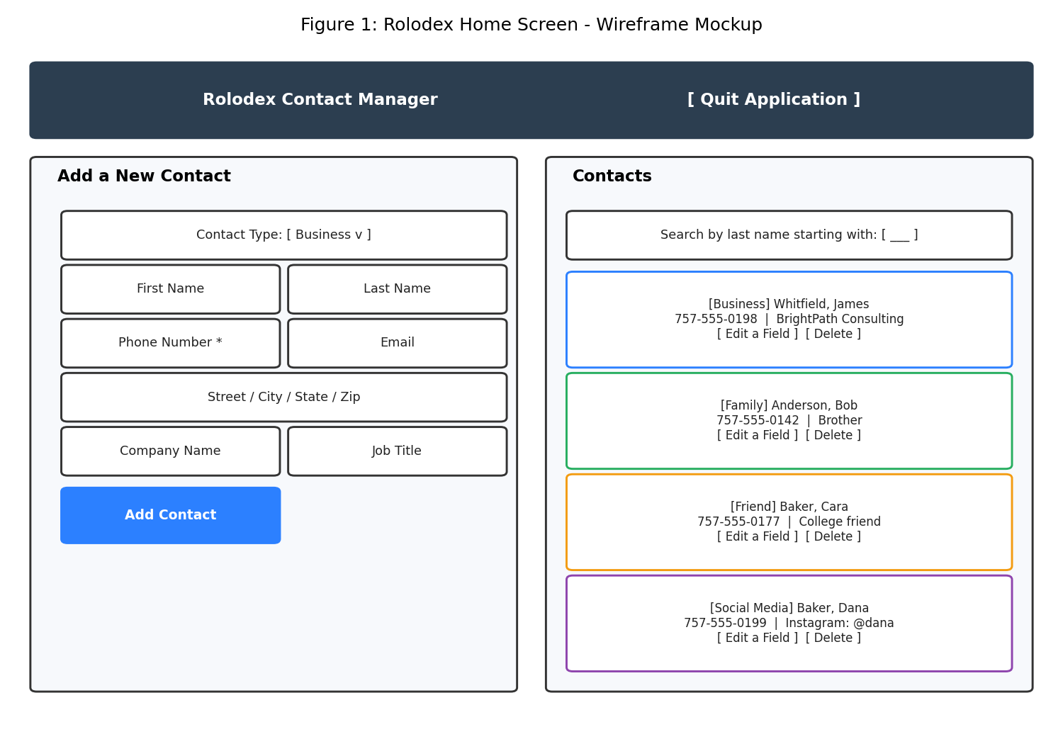
Figure 1. Planned home screen wireframe for the Rolodex Contact Manager, generated via a Python script written with the assistance of Claude (Anthropic, 2026)

Program Screenshots
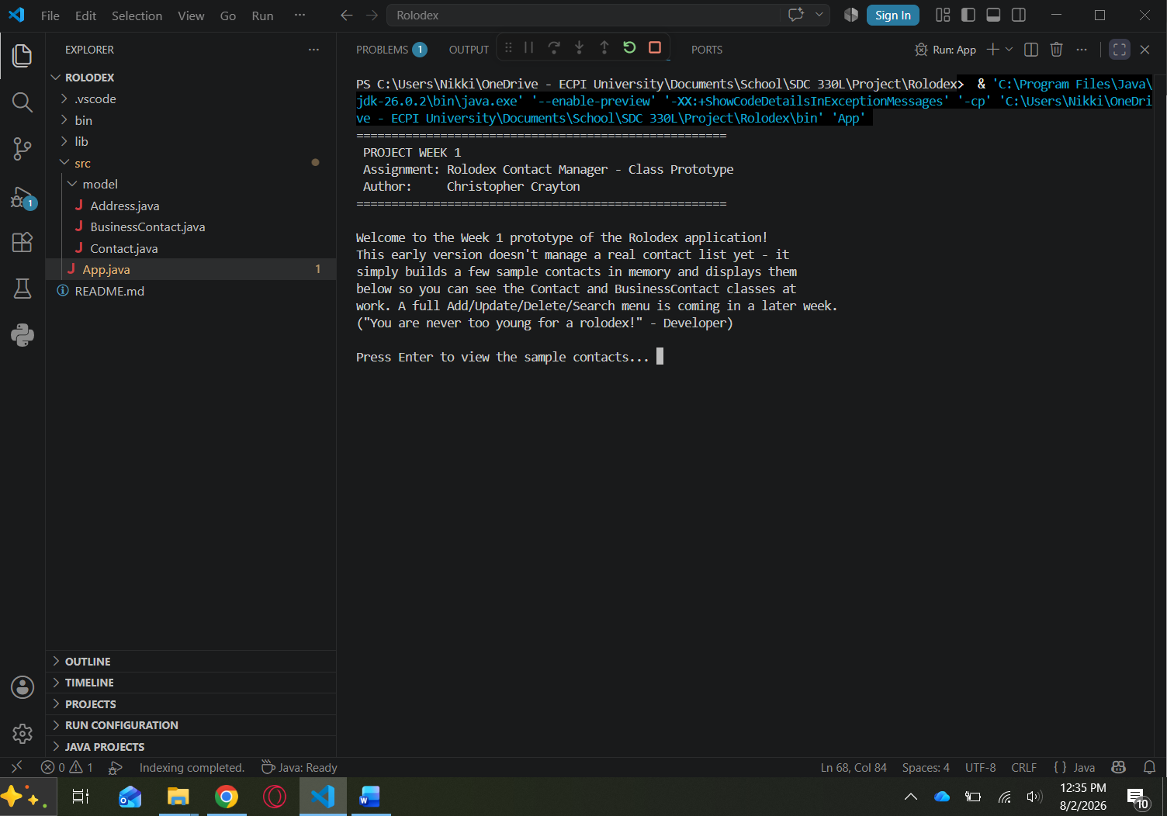
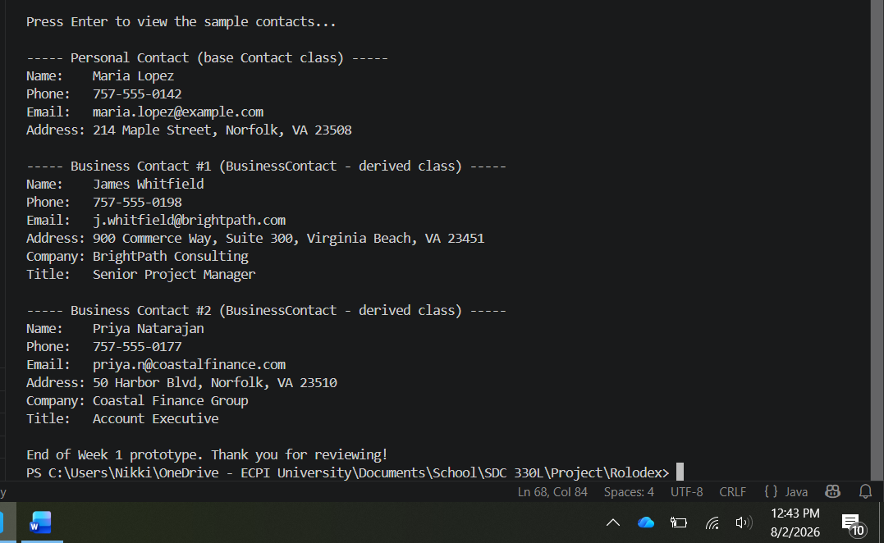
References
Anthropic. (2026). Claude (Sonnet 5) [Large language model]. https://claude.ai

